Attention: FTIR Analysis of samples are carried out at our campus, GCTS Asansol
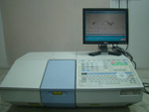
Fourier Transform Infrared Spectrophotometer (FTIR)

Charges are as follows
- For research scholars and students:
Rs 150 / sample
- For Industry:
Rs 200 / sample

Only Hard Copy (Print Out) will be provided by hand delivery or Post (Charges Apply)

